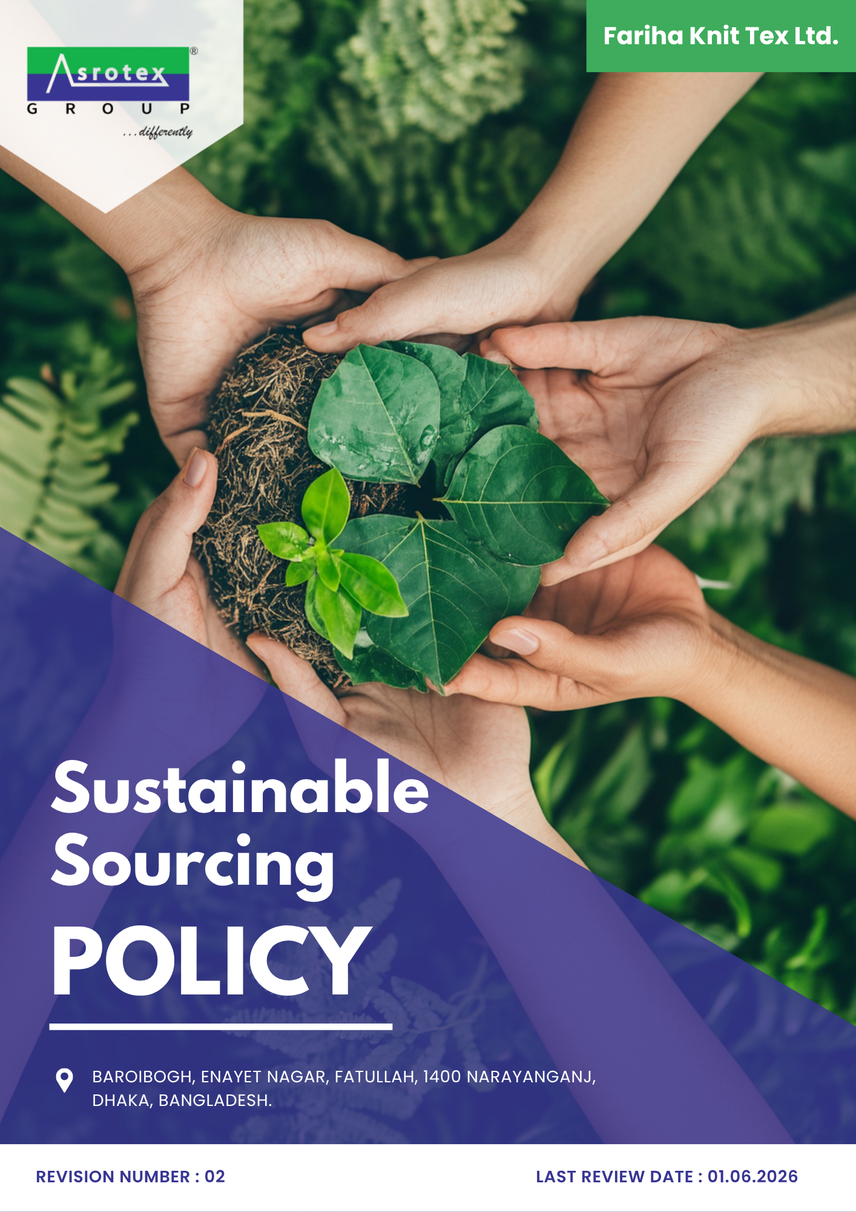

INDEX

PREFACE 3
SCOPE 3
POLICY DECLARATION 3
INITIATIVES AND TARGETS 4
ALIGNMENT WITH SDGs 6
RESPONSIBILITIES 6
REVIEW MECHANISM 7
REVISION HISTORY 7
EMPLOYEE ACKNOWLEDGMENT FORM 8

PREFACE

At Fariha Knit Tex Ltd., sustainability lies at the core of our procurement practices, reflecting our commitment to environmental stewardship, ethical labor standards, and social responsibility. This policy serves as a guiding framework to ensure that all procurement activities align with our sustainability goals while fostering long-term, transparent, and equitable partnerships with suppliers.
By integrating sustainable procurement principles, we aim to minimize environmental impact, uphold human rights, and promote ethical practices across the supply chain. This policy is a testament to our dedication to building a resilient and responsible procurement ecosystem that supports both business objectives and global sustainability goals.

SCOPE

This Policy is applicable to following sites and all of its employees, workers, sub-contractors and other stakeholders:

Sr. No. | Site | Address
1 | Fariha Knit Tex Ltd. | Baroibogh, Enayet Nagar, Fatullah, 1400 Narayanganj,  Dhaka, Bangladesh.

POLICY DECLARATION

Fariha Knit Tex Ltd. affirms its commitment to sustainable procurement as a cornerstone of our operations, using 2022 as the baseline year to measure progress and set actionable targets. Sustainability considerations are incorporated into supplier selection, evaluation, and performance monitoring to encourage continual improvement across our supply chain. We are dedicated to sourcing responsibly, reducing environmental impact, and upholding fair labor practices throughout our supply chain.

This policy outlines our principles for integrating sustainability into procurement activities, focusing on minimizing ecological footprints, protecting human rights, and fostering equitable partnerships with suppliers. By embedding these values into our processes, we aim to meet regulatory requirements, drive measurable progress, and contribute to a more sustainable and ethical future.

INITIATIVES AND TARGETS

- Supplier Environmental Practices
- To Promote supplier participation in environmental certification programs (e.g., ISO 14001, Fair Trade, etc.).
- Adhere strictly to established criteria for selecting suppliers who demonstrate a commitment to responsible environmental practices, including waste reduction, energy efficiency, and sustainable resource management and build long-term partnerships with suppliers committed to sustainability.
- Achieve 80% of suppliers obtaining recognized environmental certifications by 2030.
- Ensure 30% of procured materials are from sustainable sources (e.g., recycled, organic, etc.) by 2030.
- To implement corrective action plans for 100% of strategic suppliers identified with significant environmental risks by 2030.

- Supplier Social Practices
- To offer training sessions for suppliers on human rights and fair labor practices.
- Achieve 100% engagement of suppliers in human rights and ethical labor practices workshops by 2030.
- Ensure that 100% of suppliers have human rights policies in place by 2030.
- To ensure 100% of strategic suppliers are evaluated against social and labor criteria by 2030.

- Supplier Engagement and Capacity Building
- Build strong relationships with suppliers through transparent communication and shared sustainability goals.
- Enhance suppliers' understanding of sustainability standards through tailored training sessions.
- Launch a Supplier Development Program by 2030, engaging 80% of suppliers within the first three years.
- Recognize top 5% of suppliers annually through a Supplier Recognition Program till year 2030 and thereafter.

- Inclusive Sourcing
- To promote equal and fair opportunities for local, diverse, and small suppliers within the procurement process.
- Establish partnerships with 5% of total suppliers from diverse backgrounds, including women-owned, minority-owned, and local businesses, by year 2030, fostering collaboration and long-term growth.
- To source 20% of applicable procurement spend from local, diverse, small, or underrepresented suppliers by 2030.

- Ethical Sourcing
- To source goods and services from suppliers that demonstrate integrity, transparency, and ethical business conduct.
- Ensure traceability of raw materials to verify ethical sourcing standards.
- To ensure 100% of strategic suppliers acknowledge and comply with the Company's Supplier Code of Conduct by 2030.
- Increase the number of partnerships with certified ethical sourcing organizations by 5% by 2030.

ALIGNMENT WITH SDGs

RESPONSIBILITIES

The Sustainability Manager will lead the creation of Fariha's annual Sustainable Sourcing Performance Report, collaborating with key stakeholders for comprehensive assessment and reporting. The report will include input from:
- Sustainability Manager – Oversees policy implementation, supplier evaluations, and alignment with sustainability goals.
- Procurement Team – Selects suppliers meeting environmental and labor standards, facilitates training, and ensures ongoing compliance.
- HR and Compliance Team – Monitors supplier adherence to labor standards, addresses non-compliance, and ensures corrective actions.

REVIEW MECHANISM
The Sustainability Manager will conduct an annual review of this policy to assess its effectiveness. The review will involve evaluating supplier performance, responsible sourcing practices, and addressing non-compliance. Based on findings, updates will be made to align with ESG standards and reinforce Fariha’s commitment to sustainable sourcing.

REV. No. 02
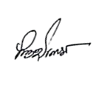
LAST REVIEW DATE: 01.06.2026 NEXT REVIEW DATE: 01.06.2027

APPROVED BY: M Shohidul Islam

REVISION HISTORY

Rev. No. | Review/Effective Date | Description of Changes | Approved By
00 | 01.06.2024 | Initial Issue
01 | 01.06.2025 | Annual policy review and update.
02 | 01.06.2026 | Initiatives and Targets topic

EMPLOYEE ACKNOWLEDGMENT FORM

I hereby acknowledge that I have received and reviewed the Sustainable Sourcing Policy of Fariha Knit Tex Ltd. I understand the company’s commitment to responsible procurement practices that prioritize environmental sustainability, social equity, and ethical standards.
By signing this document, I confirm my understanding of the policy and my role in supporting its objectives. I agree to act in accordance with the principles outlined, ensure adherence in daily operations, and report any non-compliance or concerns as per the designated procedures.

Name: Shamima Khatun
Position: Junior FQI
Signature: ______________________
Date: 07-06-2026

